
Arden University (Berlin)

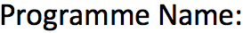
Programming for Data Analytics

COM7024


Data Analytics in Python

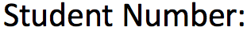
24169956

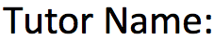
Prof. Ahmed Hassan


3,002

Table of Contents
- Introduction .................................................................... 3
- Data Understanding & Methodology ...................... 3
2.1 Brief data understanding .......................................... 3
2.2 Digital tools used ....................................................... 3
- Data Pre-processing ..................................................... 4
3.1 Initial data quality check ............................................ 4
3.2 Handling data types and invalid values ..................... 4
3.3 Handling missing data ................................................ 6
3.4 Outlier detection and treatment ................................ 7
- Exploratory Data Analysis (EDA) ............................. 9
4.1 Overview of the cleaned dataset ............................... 9
4.2 Distribution of key numerical variables .................. 10
4.3 Distribution of the target variable ........................... 10
4.4 Categorical factors and career change .................... 11
4.4.1 Gender ............................................................ 11
4.4.2 Education level ............................................... 12
4.5 Job-related attitudes and career change ................. 12
4.6 Correlation analysis ................................................. 14
- Discussion ...................................................................... 16
- Conclusion ....................................................................... 16
- References ...................................................................... 17
- Appendix A ...................................................................... 18
- Appendix B ..................................................................... 21

Introduction:

In this assignment, I’ve used a career-related dataset (Career data_PDA_4053.xlsx) for the Programming for Data Analytics (COM7024) module. The dataset contains information on 5,000 individuals and includes 21 variables that capture occupational traits, career-related factors, and demographics features for 5,000 individuals. Field of study, current occupation, age, gender, years of experience, education level, industry growth rate, job satisfaction, work-life balance, job opportunities, and salary are a few examples of variables. Career Change Interest, Skills Gap, Certifications, Freelance Experience, Geographic Mobility. Professional Networks, Career Change Events, and Technology Adoption are just a few of the variables that are recorded in the data that may have an impact on career mobility. “Likely to Change Occupation”, a binary indicator that indicates whether each person is thought to be likely to change their occupation, is the primary outcome variable. This analysis’s main goal is to preprocess the dataset and investigate the relationship between these many variables and the probability of changing careers.

Data Understanding & Methodology

2.1 Brief data understanding
There were both numerical and categorical variables in the dataset, according to the first Python examination. Age, years of experience, pay, job satisfaction, and work-life balance scores are examples of numerical features; gender, education level, field of study, current occupation, and industry growth rate are examples of categorical features. The dataset is appropriate for classification tasks in the future because the goal variable, “Likely to Change Occupation”, is stored as a binary indicator (0 = not likely, 1 = likely).

2.2 Digital tools used
All analysis was done using Python on Google Colab. Colab was selected because it offers a ready-to-use environment that doesn’t require installation and allows for notebook-style analysis. Pandas for data loading and preprocessing, NumPy for numerical calculations, and matplotlib and seaborn for visualization were the primary libraries utilized. I was able to examine data types, compute descriptive statistics, handle missing values, and create plots such as correlation heatmaps, boxplots, and histograms. I was able to work methodically with the dataset and record every stage of the research in code by using these digital tools.

Data Pre-processing

3.1 Initial data quality check
I used Python to perform a series of fundamental data quality tests before implementing any changes. I looked at the dataset’s structure, the ranges of each variable, and the quantity of missing data using functions like df.info(), df.describe(), and df.isna().sum(). In addition to confirming that the dataset contained both numerical and categorical variables, these checks also identified several problems with the raw file. A few observations had unexpected codes in binary fields, and certain variables that ought to be numerical, such as salary and some 0/1 indicators, were recorded as object (text) types. Furthermore, several columns included missing data, and the boxplots and descriptive statistics for salary indicated the existence of extreme outliers. As illustrated in Figure 3.1, it displays numerous columns with nan values and object types.
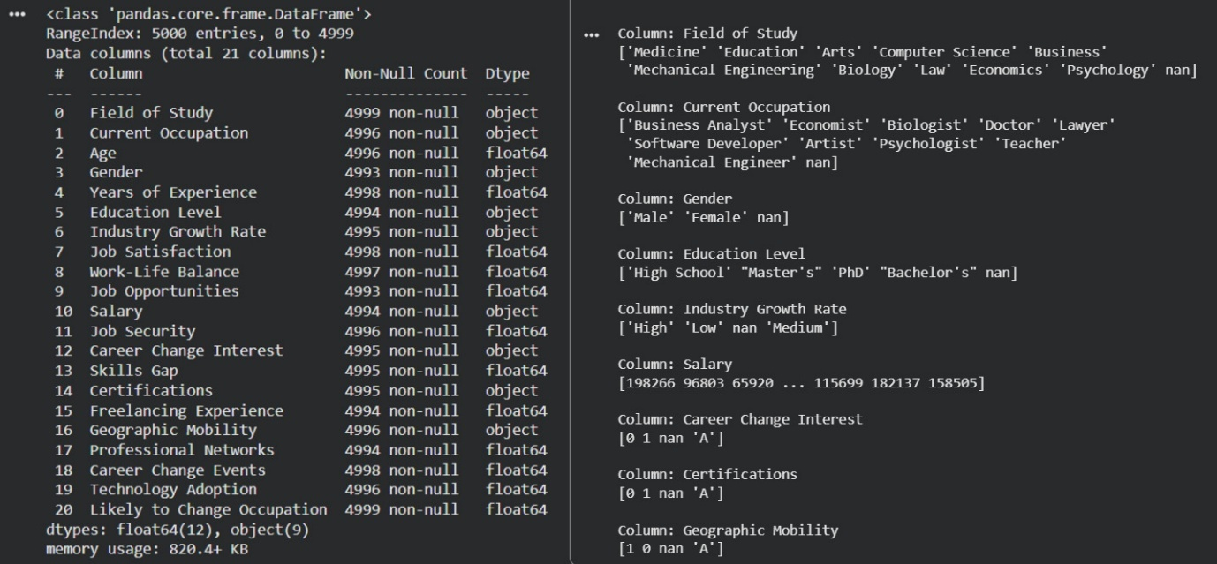
Figure 3.1: Initial structure and sample categories of the career dataset in Python.
Early detection of these issues made it easier for me to organize the preprocessing stages that followed, which concentrated on fixing data types, handling outliers before proceeding to exploratory analysis.
3.2 Handling data types and invalid values
Following my discovery of these problems, I initially concentrated on fixing the data types of various variables. Salary and a few other number fields were saved as objects (text) in the raw dataset instead of numerical values. I transformed Salary into a correct numerical column using pandas' “to_numeric” function. This adjustment was crucial because it made it possible for me to compute significant descriptive statistics, create boxplots and histograms for salary, and incorporate them into the correlation study. Additionally, I verified that other score-based variables, like work-life balance and job satisfaction, were kept in the proper numerical format.
Next, I cleaned several binary variables, such as Geographic Mobility, Certifications, and Career Change Interest. These columns included the expected 0 and 1 numbers as well as unexpected categories classified as “A”, according to an initial review. I considered this code as an invalid entry and substituted missing values (NaN) because it did not fit the binary structure and could not be safely interpreted. In order to make these variables consistent and usable for further analysis, I then changed them to a numerical 0/1 format.
Lastly, I made sure that the goal variable, “Likely to Change Occupation”, was kept as an integer indicator, where 1 meant “likely” and 0 meant “not likely”. This standardization is crucial for descriptive analysis as well as any classification models that may be developed in the future using this dataset. As shown in Table 3.1 & Figure 3.2.
Variable | Original type/issue | Cleaned type/action
Salary | Object (text) | Converted to Numeric using to_numeric
Career Change Interest | Object, values 0, 1, ‘A’ | ‘A’ → NaN, then converted to numeric 0/1
Certifications | Object, values 0, 1, ‘A’ | ‘A’ → NaN, then converted to numeric 0/1
Geographic Mobility | Object, values 0, 1, ‘A’ | ‘A’ → NaN, then converted to numeric 0/1
Likely to Change Occupation | Object / Float | Converted to Integer 0/1

Table 3.1: Summary of key variables and data-type cleaning actions.
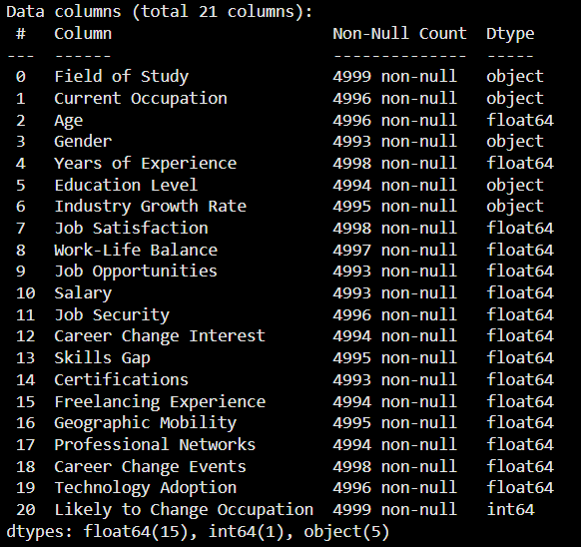
Figure 3.2: Data types and non-null counts after cleaning the dataset.
3.3 Handling missing data
To assess the amount of missing data in the dataset, I used Python’s isna().sum() function to count the number of null values in each column. Figure 3.3’s left side displays the findings. A few variables, such as Current Occupation, Age, Gender, Education Level, Industry Growth rate, Job Satisfaction, Work-Life Balance, Job Opportunities, Salary, and Career Change Interest, had a few missing items. The percentage of missing data for each feature was generally modest, ranging from one to six out of 5,000 observations.
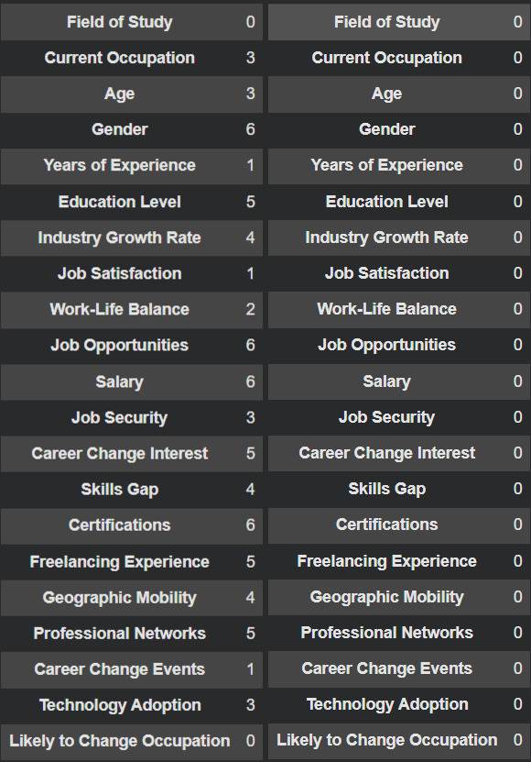
Figure 3.3:
Number of missing values per variable before imputation (left) and after imputation (right).
Rather than deleting rows from the dataset, I chose to keep all records and replace the missing values because the amount of missingness was small. For both numerical and categorical data, I used several imputation techniques. I used the median value of each column to fill in the blanks for numerical characteristics like Age, Years of Experience, Salary, Job Satisfaction, and Work-Life Balance. Because it is less sensitive to extreme values – which is crucial for variables like salary where outliers were present – the median was selected over the mean. To maintain the current distribution categories for categorical variables like gender, education level, field of study, and current occupation, I substituted the mode – the most frequent category—for missing values.
After running this imputation procedure, I checked the dataset again using isna().sum(). As shown on the right side of Figure 3, every variable now has zero missing values. This verifies that, following preprocessing, there are no missing null entries or lost observations, making the dataset full. Because it prevents bias from removing rows and guarantees that summary statistics and visualizations are based on the entire sample, having a fully populated dataset is crucial for the next exploratory data analysis and any further modeling.
3.4 Outlier detection and treatment
Plots and descriptive statistics for Salary revealed the existence of extreme outliers during the first investigation. The greatest salary value was well above the median and many times bigger than the average range, suggesting that the distribution’s general shape and mean could be significantly distorted by a small number of observations. Using the raw data, I created boxplots and salary histograms to better explore this.
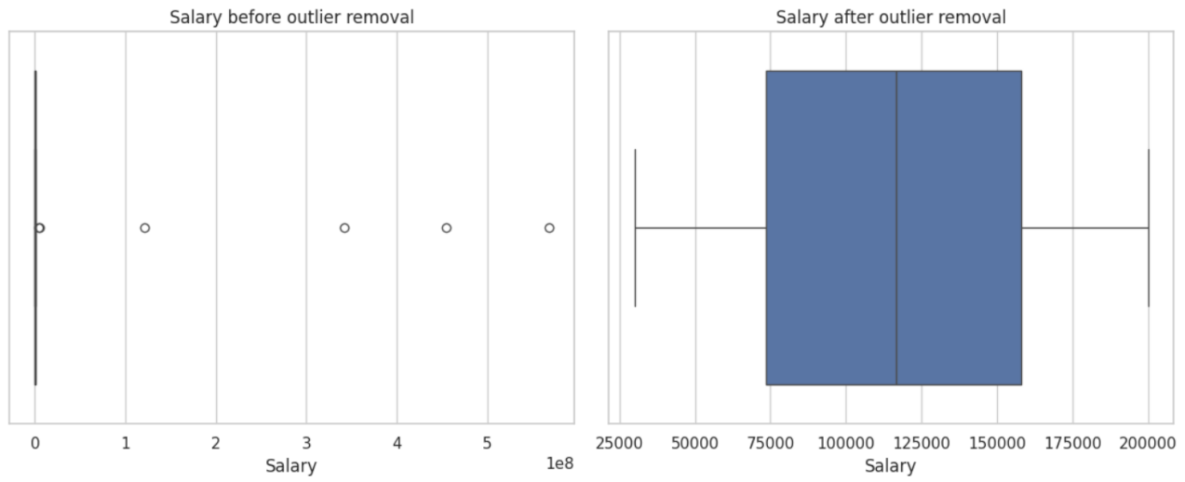
Figure 3.4: Boxplots of Salary before (left) and after (right) outlier removal.
As shown in Figure 3.4 (left), the original boxplot is dominated by several extremely high salary values, which appear as isolated points far to the right of the main distribution.
To deal with these extreme results in a systematic approach, I employed the interquartile range (IQR) method. I first determined the salary’s first and third quartiles (Q1 and Q3), and then I calculated the IQR as Q3 – Q1. Any observations with a salary below Q1 – 1.5 × IQR or above Q3 + 1.5 × IQR were considered outliers. The remaining observations were kept as the cleaned Salary values, and all rows that fell outside of these bounds were eliminated from the dataset. With this method, the distribution is not randomly trimmed; instead, only the most extreme examples are eliminated.
‘’ In total, only 6 observations (out of 5,000) were removed as Salary outliers, so the sample size remained almost unchanged.”
Interquartile Range (IQR)
Lower bound | -53446.75
Upper bound | 285167.25
No. of Salary outliers | 06
Table 3.2: IQR findings
The effect of this procedure can be seen clearly in (Figures 3.4 & 3.5). Because the extreme values stretch the x-axis, nearly all incomes are compressed into a small band close to zero before cleaning (Figure 3.5, left). The existence of extremely big outliers is confirmed by the original boxplot in Figure 3.4, which also displays several points far to the right of the main box. The cleaned boxplot (Figure 3.4, right) shows a much more condensed and comprehensible range once the IQR rule is applied, and the histogram (Figure 3.5, right) exhibits a distribution that is still right-skewed but is now focused inside a reasonable pay interval.
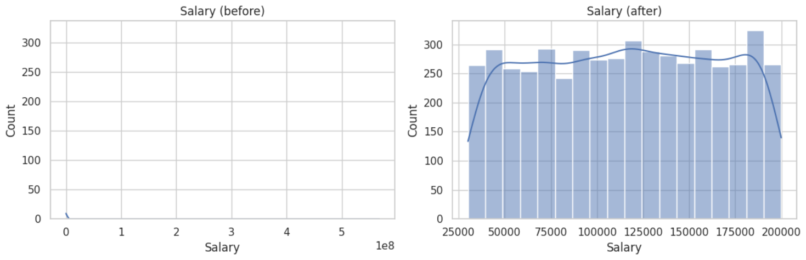
Figure 3.5: Histograms of Salary before (left) and after (right) outlier removal.
The primary summary statistics for salary before and after outlier removal are contrasted in Table 3.3. The mean salary significantly drops and approaches the median, suggesting that a small number of erroneous values have less of an impact on the cleaned data.
Statistics | Salary (before) | Salary (after)
Mean | 414,935 | 115,867
Median | 116,424 | 116,424
Std dev | 11,490,800 | 48,869
Min | 30,010 | 30,016
Max | 567,896,500 | 199,976
Skewness | 41.94 | -0.02

Table 3.3: Summary statistics for Salary before and after outlier removal
The distribution is still slightly skewed to the right, but the maximum salary falls to a far more reasonable level, and the skewness decreases. These modifications imply that the cleaned Salary variable provides a more reliable basis for further investigation.
Additionally, I compared the distributions of years of experience and age before and after using the outlier approach. The histograms of these variables were almost unchanged, indicating that the outlier handling primarily impacted inflated salary numbers rather than distorting other important characteristics.
Overall, the outlier treatment stage preserved the dataset’s fundamental structure while creating a cleaner, more realistic Salary variable. The dataset is now prepared for exploratory data analysis (EDA), as presented in the next section, with corrected data types, imputed missing values, and robust outlier handling.

Exploratory Data Analysis (EDA)

Exploratory Data Analysis (EDA) is a phase that occurs throughout the early stages of the data science life cycle and entails conducting analysis over the data. Individuals become familiar with the source data after running EDA techniques and become aware of any irregularities or anomalies that might be present in the data. Manually evaluating the data and performing all the EDA techniques might be time-consuming and tedious. Rather than building predictive models, the aim is to use summary statistics and visualisations to identify trends, check assumptions, and generate insights about the data.
In this assignment, EDA is used to examine how demographics, job-related, and career-related variables have an effect after preprocessing, and to see how they are going to relate to the target variable “Likely to Change Occupation”. The distribution of important characteristics is shown in the following subsections, which also look at the aspect that seems to be most closely linked to the chance of changing careers.
4.1 Overview of the cleaned dataset
I conducted an exploratory analysis using the cleaned dataset (4,994 observations and 21 variables) following the preprocessing outlined in Section 3. At this point, all features had the proper data types, there were no more missing values, and the IQR technique had eliminated severe salary outliers. This ensured that the relationships between variables, summary statistics, and visualizations were founded on reliable and consistent values. Age and Years of Experience distributions hardly changed after outlier handling, as shown in Figure 4.1. The distribution of important factors and their relationship to the probability of changing occupations are examined in the following subsections.

4.2 Distribution of key numerical variables
The distribution of Age and Years of Experience is shown in Figure 4.1. Both variables are spread across a wide range of values, with Age roughly covering 21 – 59 years and Years of Experience ranging from 0 – 39 years. The nearly identical appearance of the before and after plots indicates that Salary was the primary variable changed by the outlier treatment and that these variables were not distorted.
The cleaned salary distribution (Figure 3.5, right) indicates that most people make between 30,000 and 200,000 annually. Although there are no longer any ridiculous extreme values dominating the scale, the curve is somewhat tilted to the right, suggesting that higher salaries are less usual. This gives a more accurate picture of the sample’s average income levels.
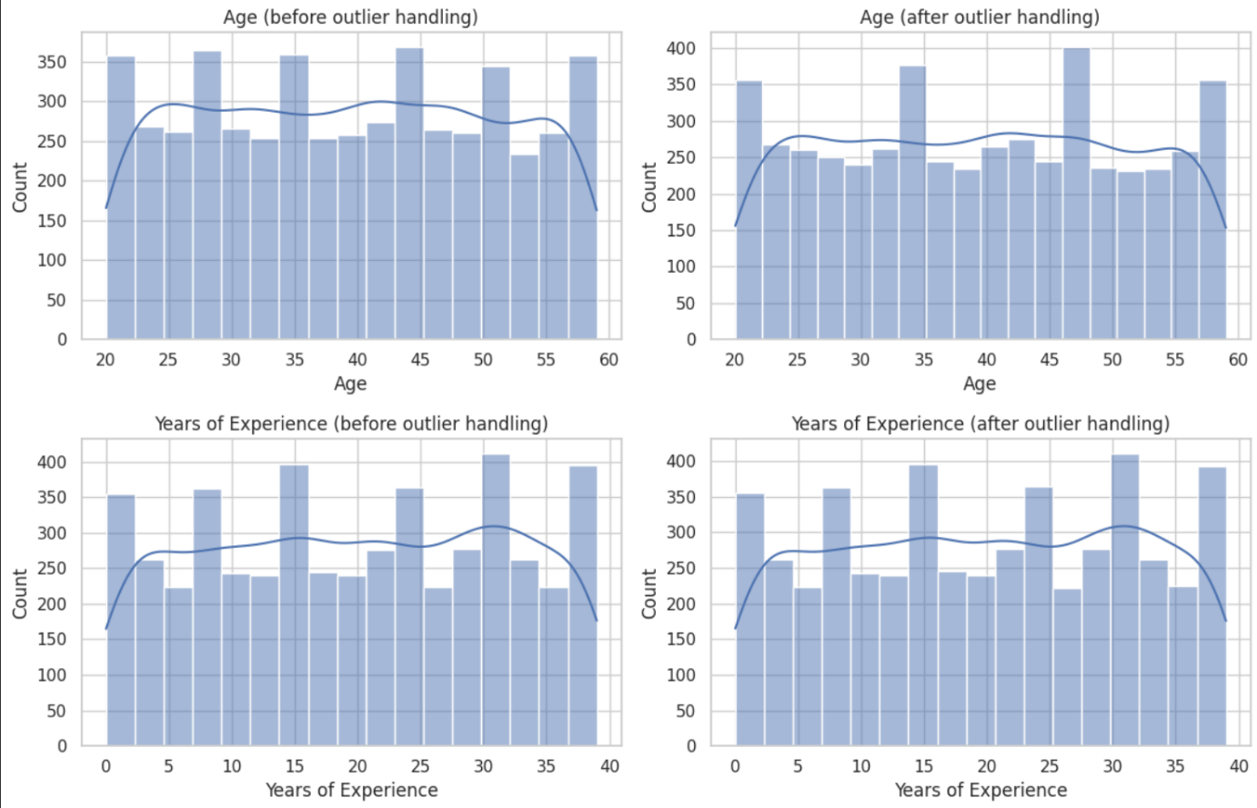
Figure 4.1: Distributions of Age and Years of Experience before (left) and after (right) outlier handling.
4.3 Distribution of the target variable
The distribution of the goal variable “Likely to Change Occupation” is displayed in Figure 4.2. Out of the 4,993 people in the cleaned dataset, 2,143 (42.9%) are classified as Not likely (0) and 2,850 (57.1%) as Likely (1) to change career. As a result, there is a minor imbalance in the classes, with a greater percentage of prospective job changers. A straightforward model that consistently forecasts “Likely to change” would already attain an accuracy of 57%, so while this isn’t severe, it is crucial to bear in mind for any future modelling.
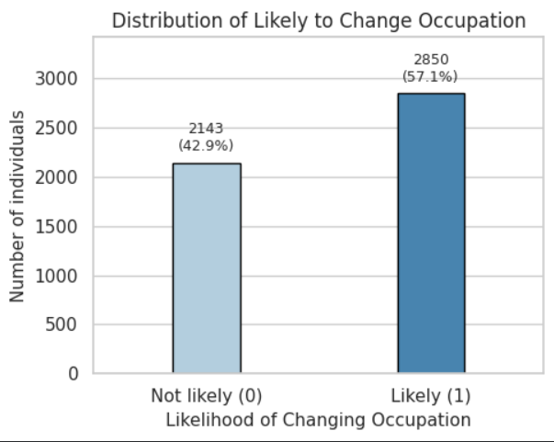
Figure 4.2: Distribution of Likely to Change Occupation (0 vs 1 bar chart with counts & %)
4.4 Categorical factors and career change
4.4.1 Gender
The relationship between gender and the likelihood of changing occupation is illustrated in Figure 4.3. The distribution for males and females is similar: approximately 42 – 44% of people in each gender are categorized as not likely to change their occupation, while approximately 56 – 58% are classed as likely to do so. The minimal gender disparities in this dataset imply that a person’s intention to change career is not significantly influenced by their gender alone.
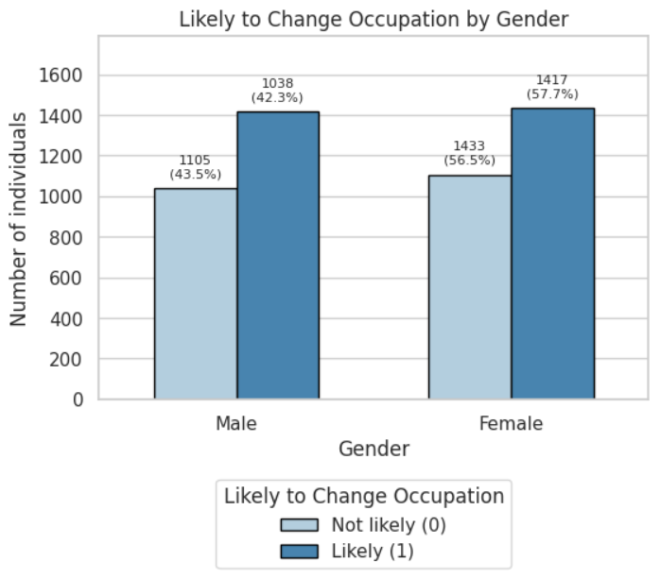
Figure 4.3: Likely to Change Occupation by Gender (grouped bar chart with percentages).

4.4.2 Education level
Figure 4.4 shows the distribution of the target variable across education levels. The percentage of people who are likely to change careers for each category – High School, Bachelor’s, Master’s, and PhD – all hover around 50% (approximately 49-51% in each group). Increased or lower education does not appear to be associated with a significantly increased likelihood of changing careers. This suggests that traits to change career exist at all levels of education and are likely influenced more by ideas and work experiences than by education alone.
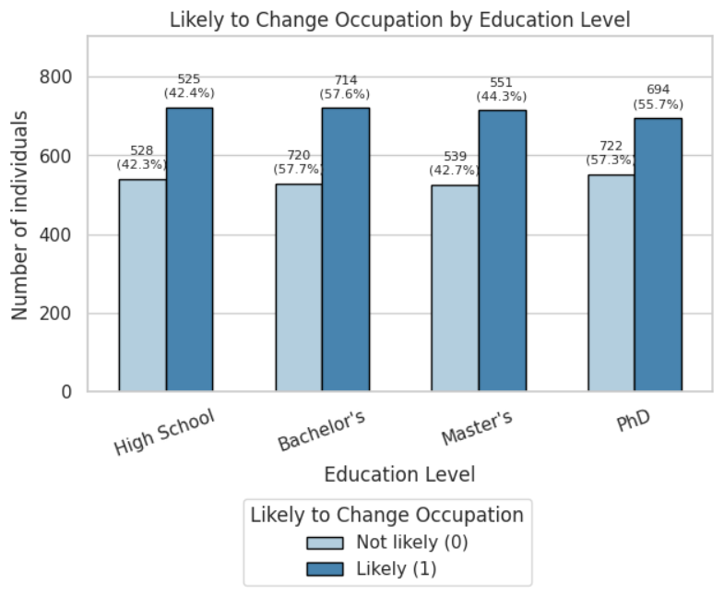
Figure 4.4: Likely to Change Occupation by Education Level (grouped bar chart).

4.5 Job-related attitudes and career change
I’ve compared mean scores for several variables between the two target groups (Table 4.1) and used a boxplot to visualize work satisfaction (Figure 4.5) to investigate which job-related aspects are most strongly associated with the possibility of changing occupations. The group means reveal that age and years of experience are nearly the same for those who are inclined to change careers and those who aren’t (both around 39 years and 19 – 20 years of experience), suggesting that demographic traits alone do not significantly influence intentions to change careers.

Likely to Change Occupation | Age | Years of Experience | Salary | Job Satisfaction | Work-Life Balance | Skills Gap | Career Change Events
0 | 39.35 | 19.66 | 125562.68 | 7.49 | 5.58 | 5.61 | 1.01
1 | 39.37 | 19.83 | 108577.27 | 3.99 | 5.47 | 5.47 | 0.98

Table 4.1: Group means table (Age, Years of Experience, Salary, Job Satisfaction, Work-Life Balance, Skills Gap, Career Change Events) by target.
On the other hand, there are significant differences in job satisfaction between the two groups. On a scale of 1—10, people who are unlikely to change careers report an average level of satisfaction of roughly 7.5, while those who are likely to do so report an average of 4.0. This trend is supported by the boxplot in Figure 4.5, which shows that the “likely” group has a median satisfaction of about 3, with scores concentrated in the lower half of the scale, while the “not likely” group has a median contentment of about 7, with most scores falling between 6 & 9. This suggests that job satisfaction and the probability of changing careers are strongly negatively correlated.

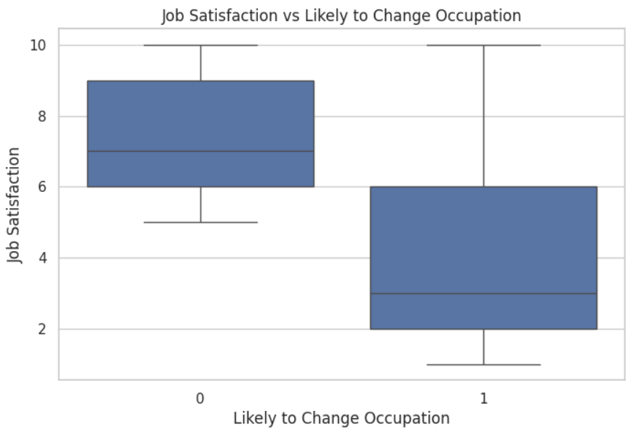
Figure 4.5: The Job Satisfaction boxplot vs Likely to Change Occupation.

Other variables show smaller differences. Although the effect is less noticeable than for satisfaction, the average salary for people who are likely to change careers is somewhat lower (approximately 108,000 vs 126,000), indicating that lower income may be a factor. The means of Work-Life Balance, Skills Gap, and Career Change Events are quite similar between the two groups, suggesting that they might have less of an impact when taken separately.
4.6 Correlation analysis
The correlation matrices for the numerical variables before and after data cleaning are shown in Figures 4.6 & 4.7. The general pattern is remarkably similar in both versions, indicating that the relationship between variables was not significantly distorted by the preprocessing procedures. Most correlations between predictors are near zero, which suggests that the variables capture distinct aspects of participants’ circumstances and indicates minimal multicollinearity.
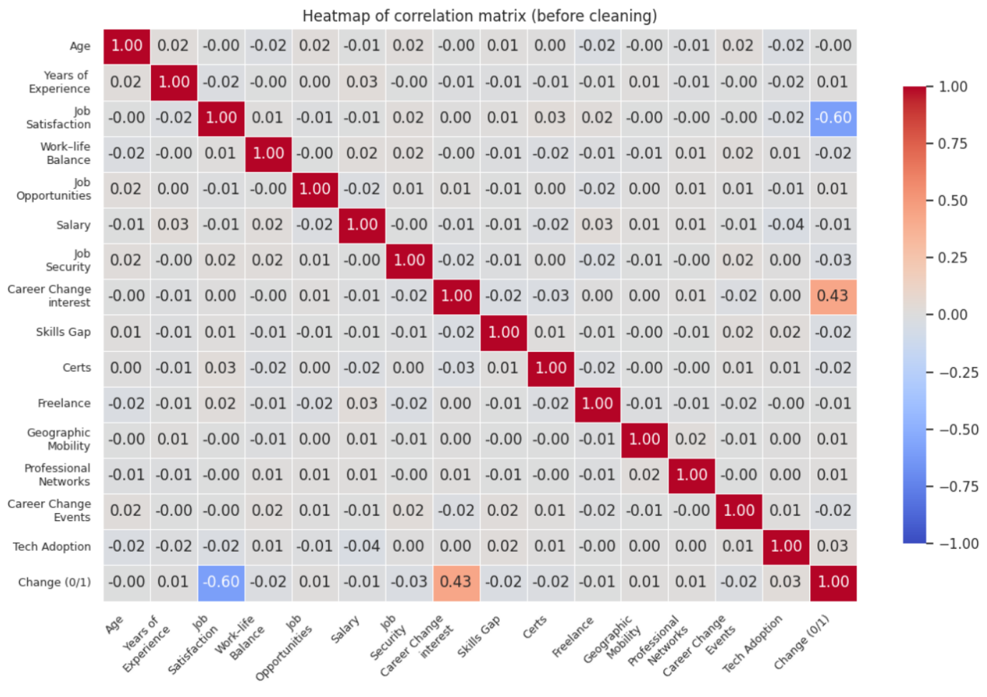
Figure 4.6: Heatmap of correlation matrix (before cleaning).
There are two noteworthy correlations with the goal of the variable. Higher job satisfaction is linked to a significantly reduced chance of changing careers, as evidenced by the large negative correlation between job satisfaction and “Change (0/1)” (roughly -0.60). On the other hand, Career Change Interest shows a positive correlation of roughly 0.43, meaning that those who show a greater desire to change occupations are more likely to be categorized as potential career changers. Following cleaning, unreasonable salary outliers are eliminated, resulting in a somewhat greater negative correlation between Salary and the goal (around -0.17). All other correlations with the aim are low, implying that attitudinal variables (satisfaction and interest) are more relevant than demographic or structural factors.
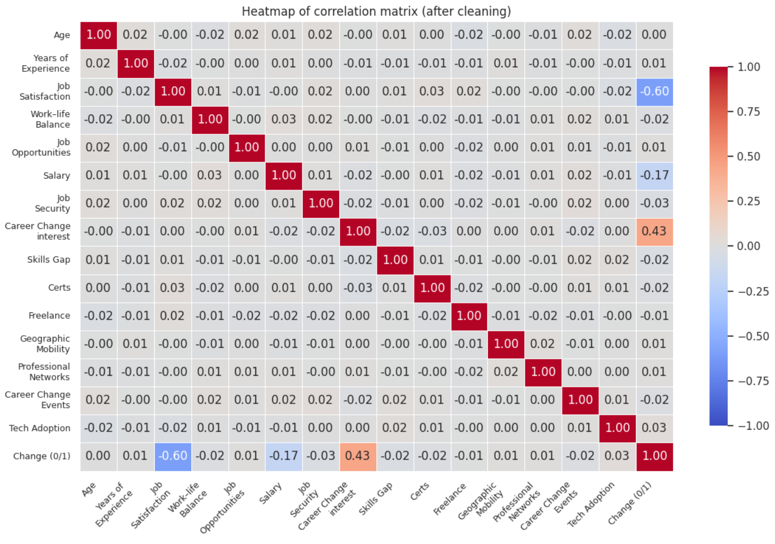
Figure 4.7: Heatmap of correlation matrix (after cleaning).

Overall, the Exploratory Analysis (EDA) indicates that stated interest in change and work satisfaction are more important factors influencing career-change intentions in this dataset than age, experience, education, or gender.

Discussion

The analysis shows that just over half of respondents (around 57%) are classified as likely to change occupation. The mean values for years of experience and age are nearly the same for the two target classes, and this trend is impressively stable across gender and educational groupings. Therefore, in this dataset, demographic factors seem to have very little bearing on plans to change careers.
In contrast, job-related attitudes are much more informative. Those who are likely to change careers have significantly lower job satisfaction, and there is a strong positive correlation between the aim and career change interest. This is verified using correlation analysis: Career Change Interest has a somewhat positive association with “Change (0/1)”; however, Job Satisfaction has a substantial negative correlation. After excluding extreme outliers, salary has a weaker negative association, indicating that while income may contribute, but is not the primary driver.
These findings have practical implications. Career services should concentrate on finding individuals who have a high interest in changing occupations or low job satisfaction and provide them with tailored advice. The cross-sectional, self-reported character of the study and the fact that some factors are conceptually close to the target, which means the results show association rather than causation, are its limitations.

Conclusion

This project demonstrated how Python and Google Colab can be used to clean, explore, and interpret a real career dataset. A better grasp of the entire analytics pipeline and the need for repeatable code was obtained by working through data-type checks, missing-values imputation, outlier handling, and visualization.
Overall, the study underlines the potential for data-driven evidence to improve career-advice practice and indicates that declared desire for change and work satisfaction are more significant determinants influencing career-change intentions than age, experience, education, or gender.

References

- Pitroda, H. (2022) ‘A proposal of an interactive web application tool QuickViz: to automate exploratory data analysis’, 2022 IEEE 7th International Conference for Convergence in Technology (I2CT). [Online]. Available at: https://research.ebsco.com/ (Accessed: 10 November 2025).
- Pandas (n.d.) pandas.DataFrame.describe — pandas’ documentation. [Online]. Available at: https://pandas.pydata.org/pandas.DataFrame (Accessed: 10 November 2025).
- Pandas (n.d.) pandas.to_numeric — pandas’ documentation. [Online]. Available at: https://pandas.pydata.org/pandas.to_numeric (Accessed: 10 November 2025).
- Pandas (n.d.) pandas.isna — pandas’ documentation. [Online]. Available at: https://pandas.pydata.org/pandas.isna (Accessed: 10 November 2025).
- Seaborn (n.d.) seaborn.countplot. [Online]. Available at: https://seaborn.pydata.org/seaborn.countplot (Accessed: 10 November 2025).
- Seaborn (n.d.) seaborn.histplot. [Online]. Available at: https://seaborn.pydata.org/seaborn.histplot (Accessed: 10 November 2025).
- Seaborn (n.d.) seaborn.boxplot. [Online]. Available at: https://seaborn.pydata.org/seaborn.boxplot (Accessed: 10 November 2025).
- Seaborn (n.d.) seaborn.heatmap. [Online]. Available at: https://seaborn.pydata.org/seaborn.heatmap (Accessed: 10 November 2025).
- Matplotlib (n.d.) Pyplot — API overview. [Online]. Available at: https://matplotlib.org/pyplot_summary (Accessed: 10 November 2025).
- Matplotlib (n.d.) matplotlib.pyplot.subplots. [Online]. Available at: https://matplotlib.org/matplotlib.pyplot.subplots (Accessed: 10 November 2025).
- NIST/SEMATECH (n.d.) Box Plot — NIST/SEMATECH e-Handbook of Statistical Methods. [Online]. Available at: https://www.itl.nist.gov/boxplot (Accessed: 10 November 2025).

Appendix A – Code listings

A.1 Data import & type fixes

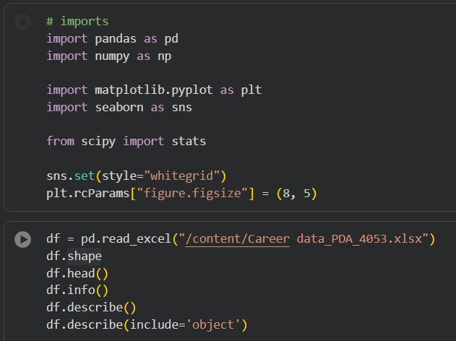
Figure A.1.1: Imports

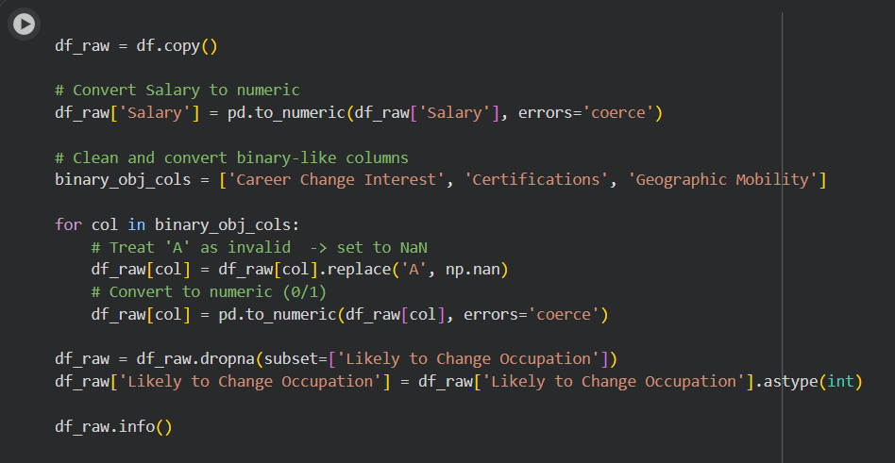
Figure A.1.2: Data Type fixes

A.2 Missing-value imputation (numeric: median; categorical: mode)

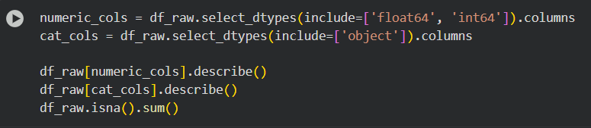
Figure A.2.1: Numeric and categorical before type fixing

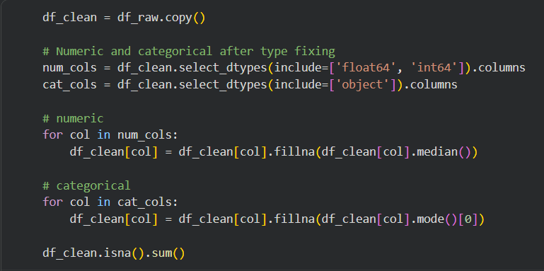
Figure A.2.2: Numeric and categorical after type fixing

A.3 Outlier handling (IQR rule for Salary)

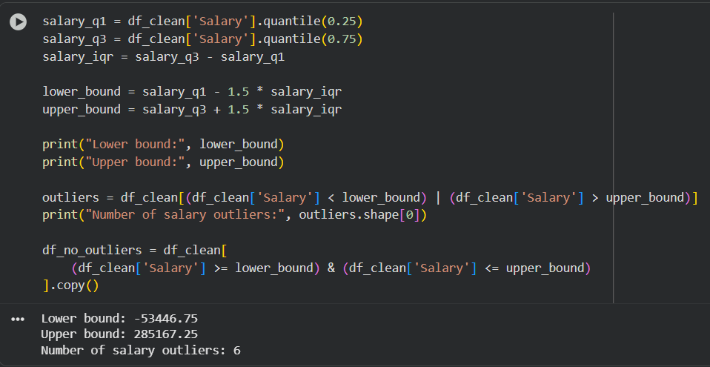
Figure A.3.1: Outlier handling (IQR rule for Salary)

A.4 EDA Plot

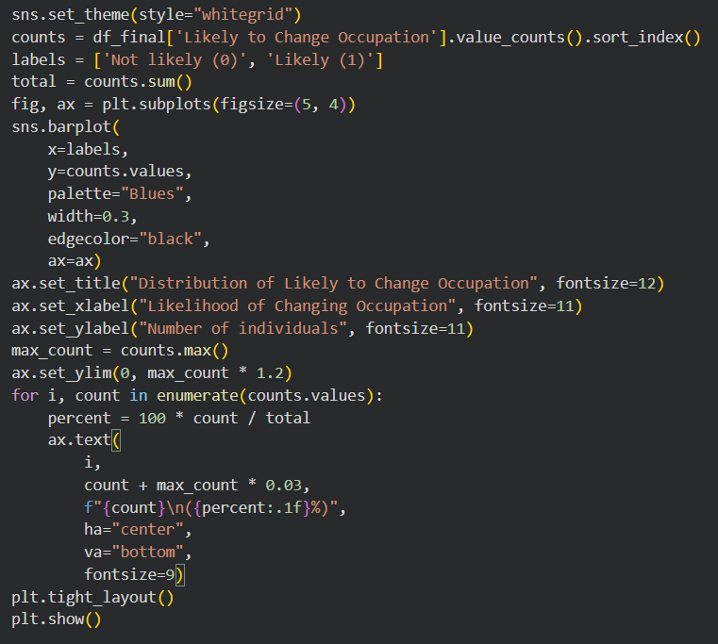
Figure A.4.1: Bar plot - Distribution of Likely to Change Occupation

Appendix B – GitHub

- Python version in Google Colab environment: 3.12.12
- GitHub: mirzasameer2000/Programming_for_Data_Analytics_COM7024
- Dataset: Career data_PDA_4053.xlsx
- Dataset after cleaning: career_data_cleaned.csv
- Colab notebook: 24169956_Programming_for_Data_Analytics_COM7024_[4053].ipynb
- Project Documentation: 24169956 - Programming for Data Analytics -COM7024 [4053].pdf

